CS 459: Software Engineering Senior Project

Spring 2025

Detailed Design Documentation

| Project Title | HCAR Client Database |
| --- | --- |
| Sponsoring Company | Humboldt Community Access and Resource Center |
| Sponsor(s) | Pennie Lee, Kim Nash, Wes Patterson |
| Students | 1. [Orlando Trujillo-Ortiz](mailto:ot26@humboldt.edu) 2. [Carson Gustafson](mailto:cjg107@humboldt.edu) 3. [Justin Crittenden](mailto:jlc246@humboldt.edu) 4. [Michael Goodwyn](mailto:mjg165@humboldt.edu) |

ABSTRACT

TABLE OF CONTENTS

LIST OF FIGURES

LIST OF TABLES

INTRODUCTION

This Detailed Design Document outlines the user interaction with different aspects of the systems associated with this project. Sequences of possible events the user will encounter with the system are included in the dynamic model through various sequence diagrams. The Graphical User Interface (GUI) for this project is categorized through storyboards to explore possible paths that the user can take when navigating the wireframe designs. The classes of the project with their design elements are shown through the static class diagrams included in this document.

Traceability and rationale for decisions made on creating the design for the systems in this project are included in their respective sections of this document, preceding the engineering standards, constraints, and references relevant to this document’s material.

GUI (Graphical User Interface) Design

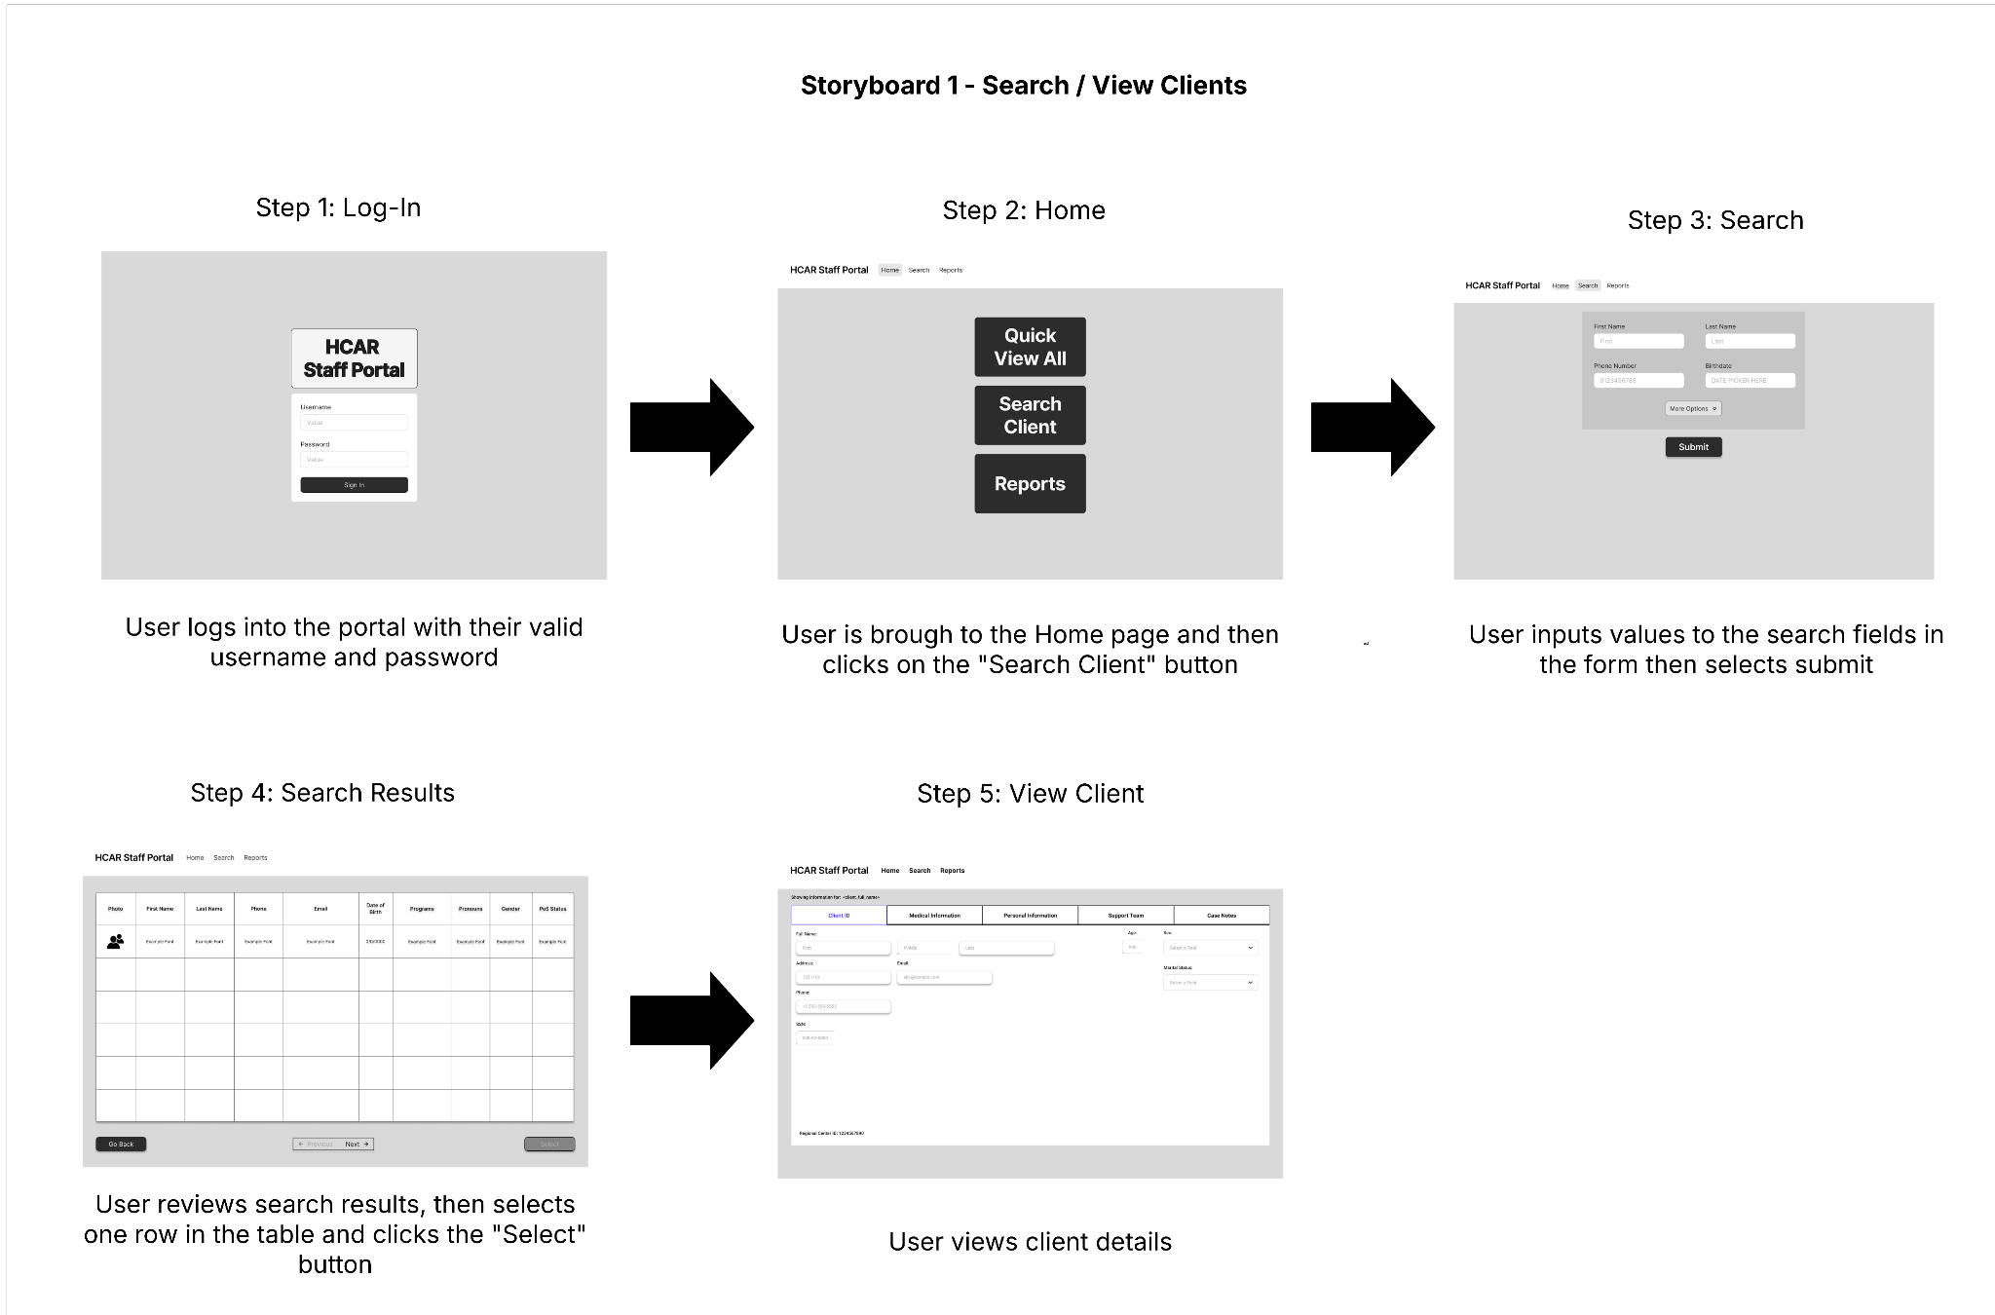

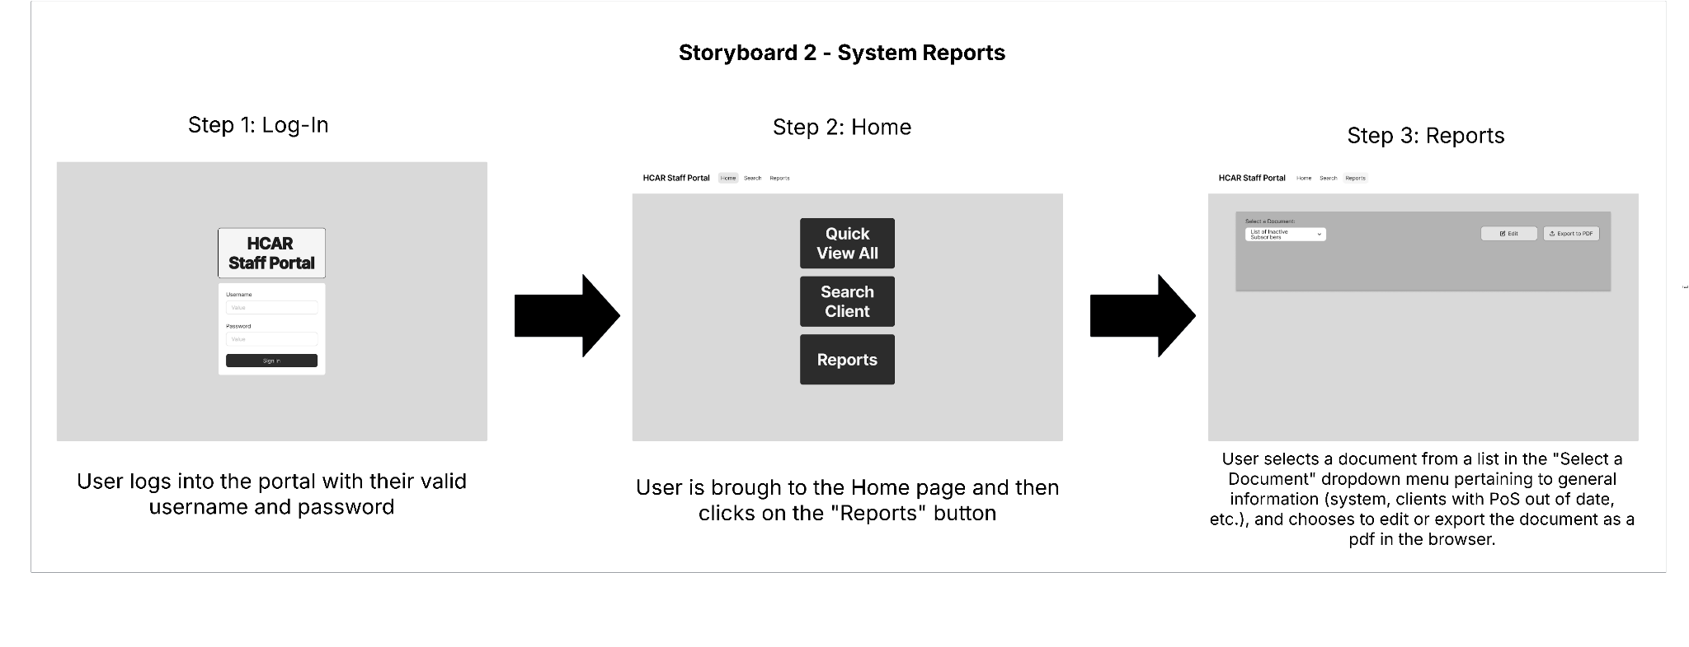

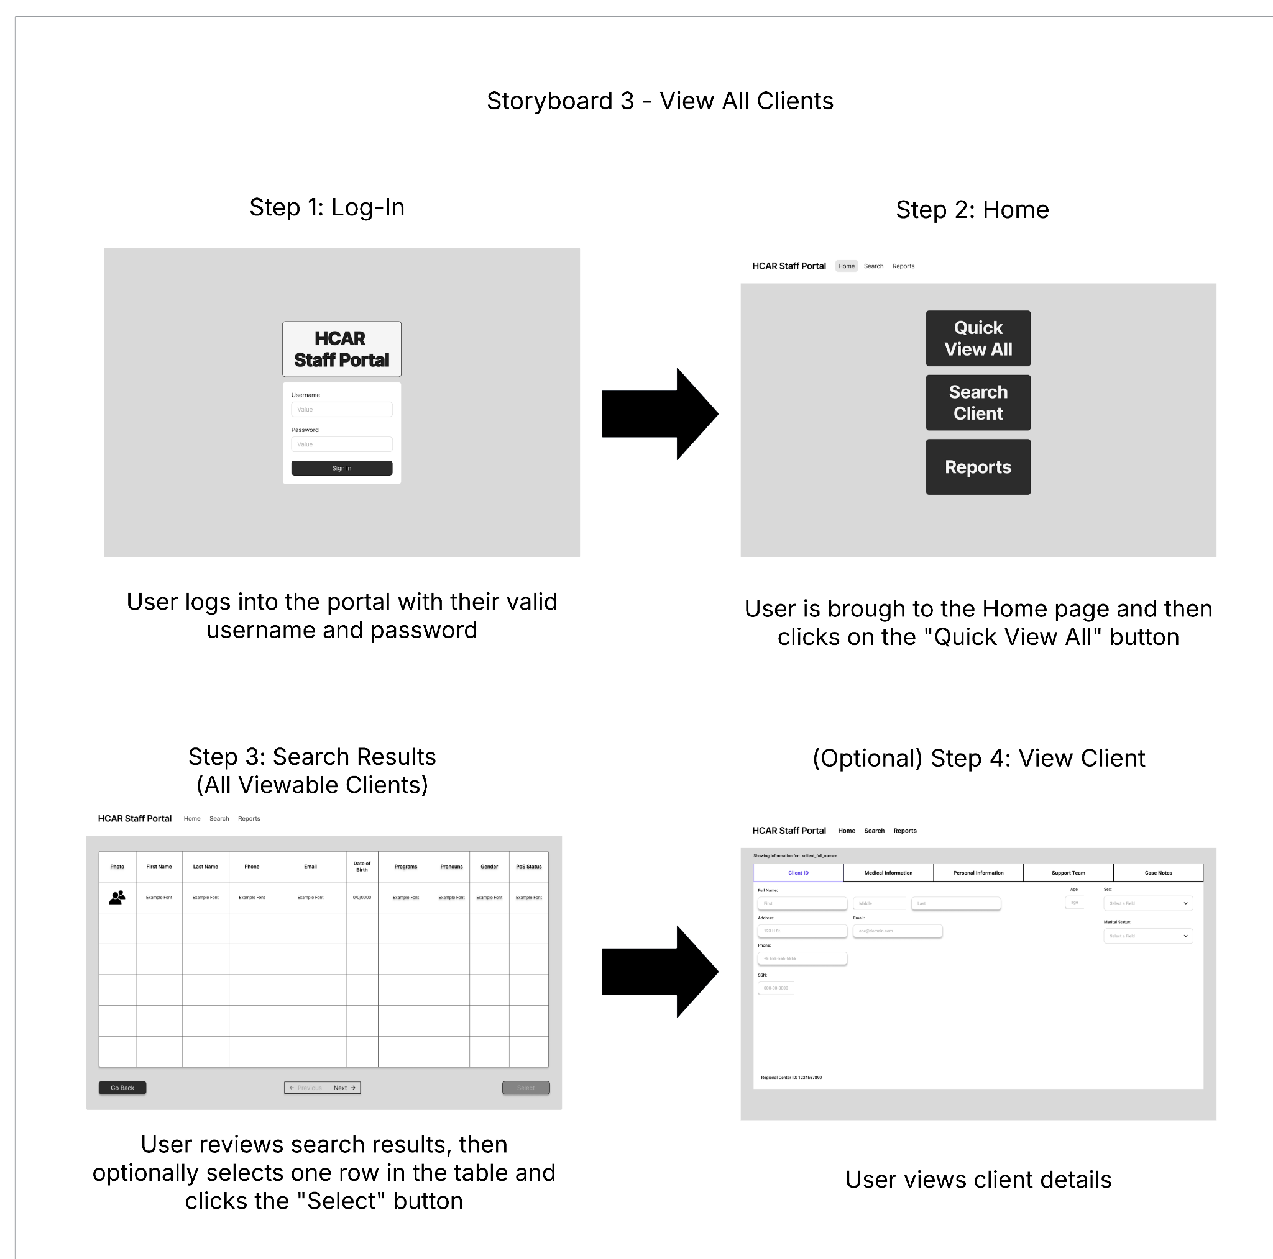

STATIC MODEL

CLASS DIAGRAMS

DYNAMIC MODEL

SEQUENCE DIAGRAMS

RATIONALE FOR YOUR DETAILED DESIGN MODEL

* Design Patterns

TRACEABILITY FROM REQUIREMENTS TO DETAILED DESIGN MODEL

* provide a mapping between requirements (user story or use case) and detailed design model (your classes/diagrams)
* clearly describe how each requirement (user story or use case) in the *Requirements Documentation* is captured in the design (your classes/diagrams)

EVIDENCE THE DESIGN MODEL HAS BEEN PLACED UNDER CONFIGURATION MANAGEMENT

ENGINEERING STANDARDS AND MULTIPLE CONSTRAINTS

* students should work with their project sponsor(s) to identify all the standards and constraints that should be applied for preparing this document

ADDITIONAL REFERENCES

* include other related references that are not included the section above